Play Chess Online
Step 1
Visit: https://www.chess.com/play/computer

Step 2
This is the home page.
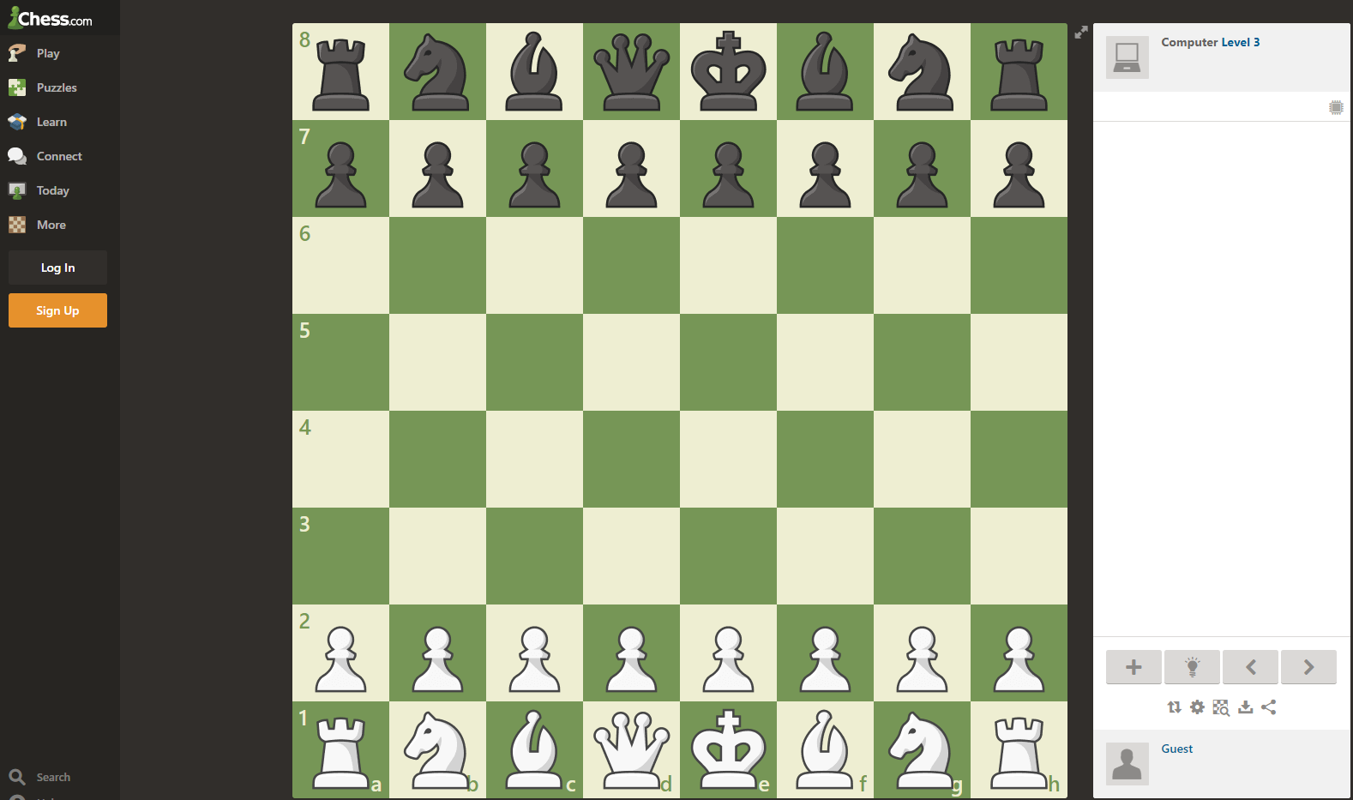

Step 3
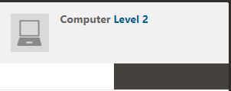
In the top right corner of the page click on the level to change the difficulty. Challenge yourself!

Step 4
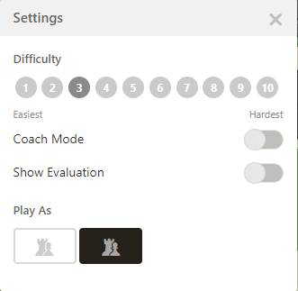
When selecting your difficulty level you can turn ‘Coach Mode’ and ‘Show Evaluation’ on or off. Difficulty ranges from easy to grandmaster.

Step 5
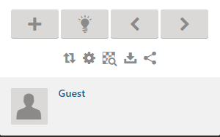
In the bottom right corner you will see these options to help you navigate your chess match.

Step 6

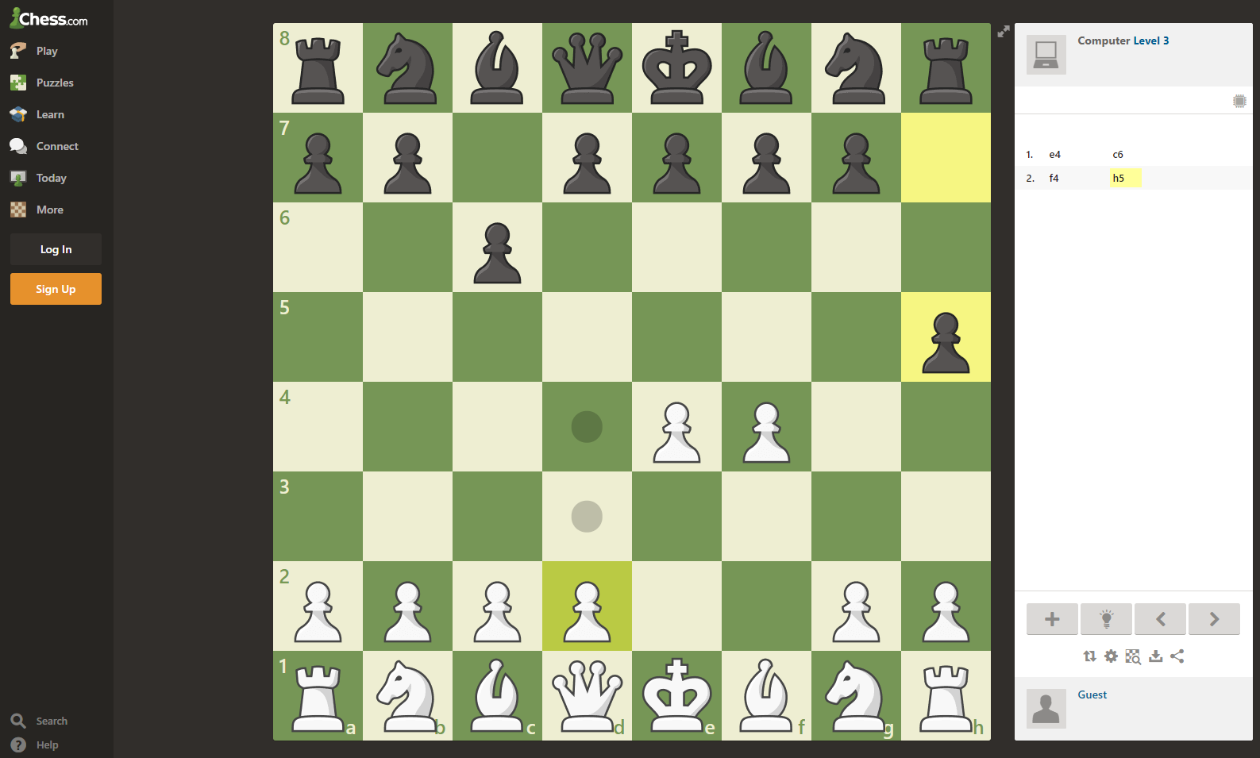
During match play the board highlights with dots to show you where the pieces can move.

Step 7
Any chess questions please contact the school and ask for Mr Hopson.

